Setting Up The Barcode Scanner

- Press and hold down the small Power Button (for three seconds) until the LED light turns blue and the scanner beeps twice.
  - The LED should blink blue once per second: This means the scanner is turned on, but not paired to the POS yet.

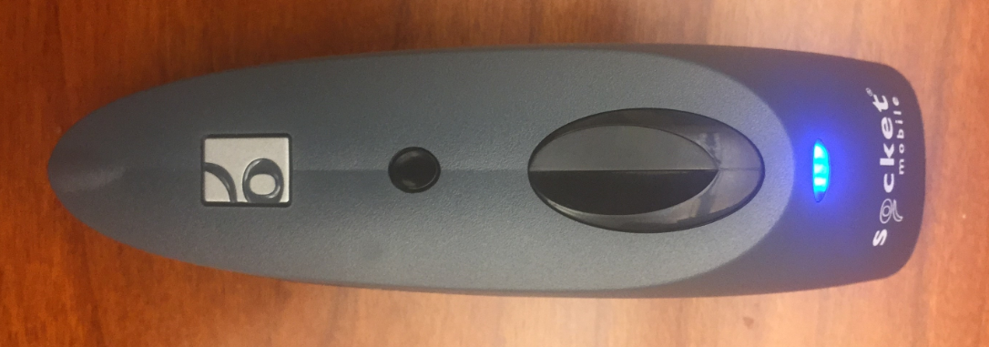
Power Button Button
LED
Scan Button

- On your iPad, open the Settings menu 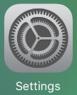 and select Bluetooth. Bluetooth must be active on your iPad for the Scanner to connect to your POS. Keep this menu open. See below image
  - DO NOT connect to the Socket CHS (Bluetooth Scanner) yet.

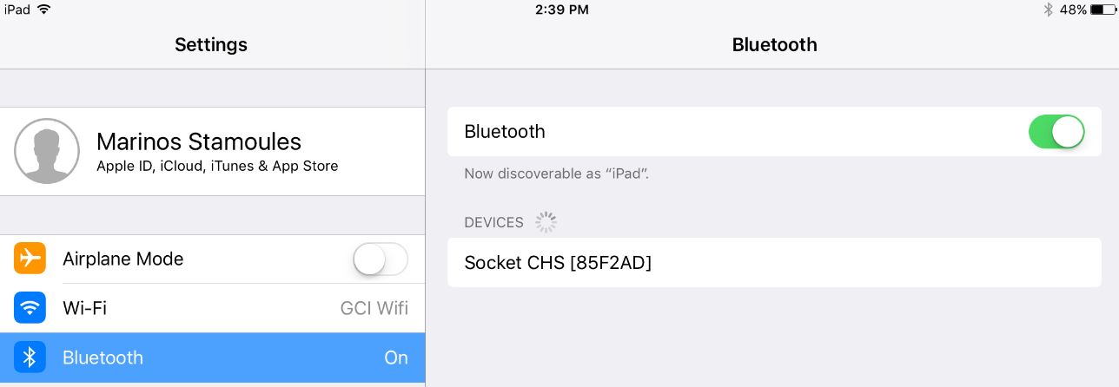

- Press the large Scan Button on the Handheld Scanner and scan the following barcode:
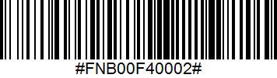
  - Several confirmation beeps will be heard from the scanner, the scanner is now broadcasting that it is pairable by Bluetooth.
- On your iPad, a device should be discoverable in your Bluetooth menu titled “Socket CHS [######]”. (The # symbols will be different for each scanner used.) Tap the “Socket CHS [######]” line on the iPad to connect to the Bluetooth scanner. See below image

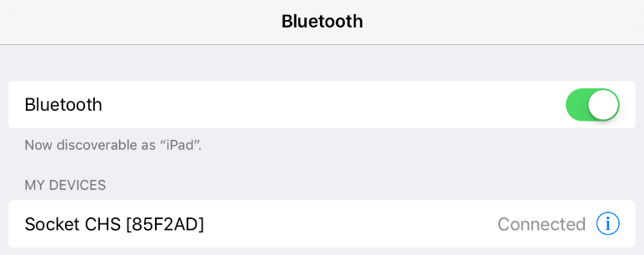

- The Handheld Scanner is now connected to the iPad!
- Close out of the Settings App and open the NCR Silver app. 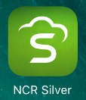
  - Use a Store Managers pin to log into the app
- Top-left corner of the NCR Silver POS screen select  to access the menu (the button looks like three parallel horizontal lines)
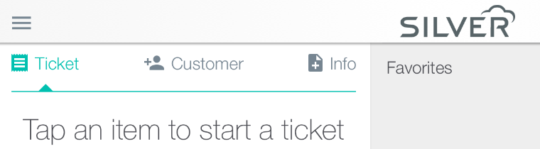
- Select Settings within this Menu (located near the bottom of the screen).
- Within the Options menu (defaults here)
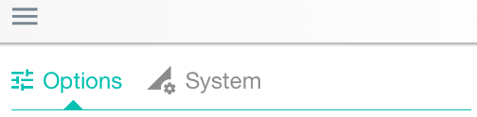
  - Scroll to the bottom of the options menu and select: Use Bluetooth Barcode Scanner (the slider will appear Green once selected. See example image



- Once the Bluetooth Barcode Scanner is paired, the LED will blink blue once per every 3 seconds.

